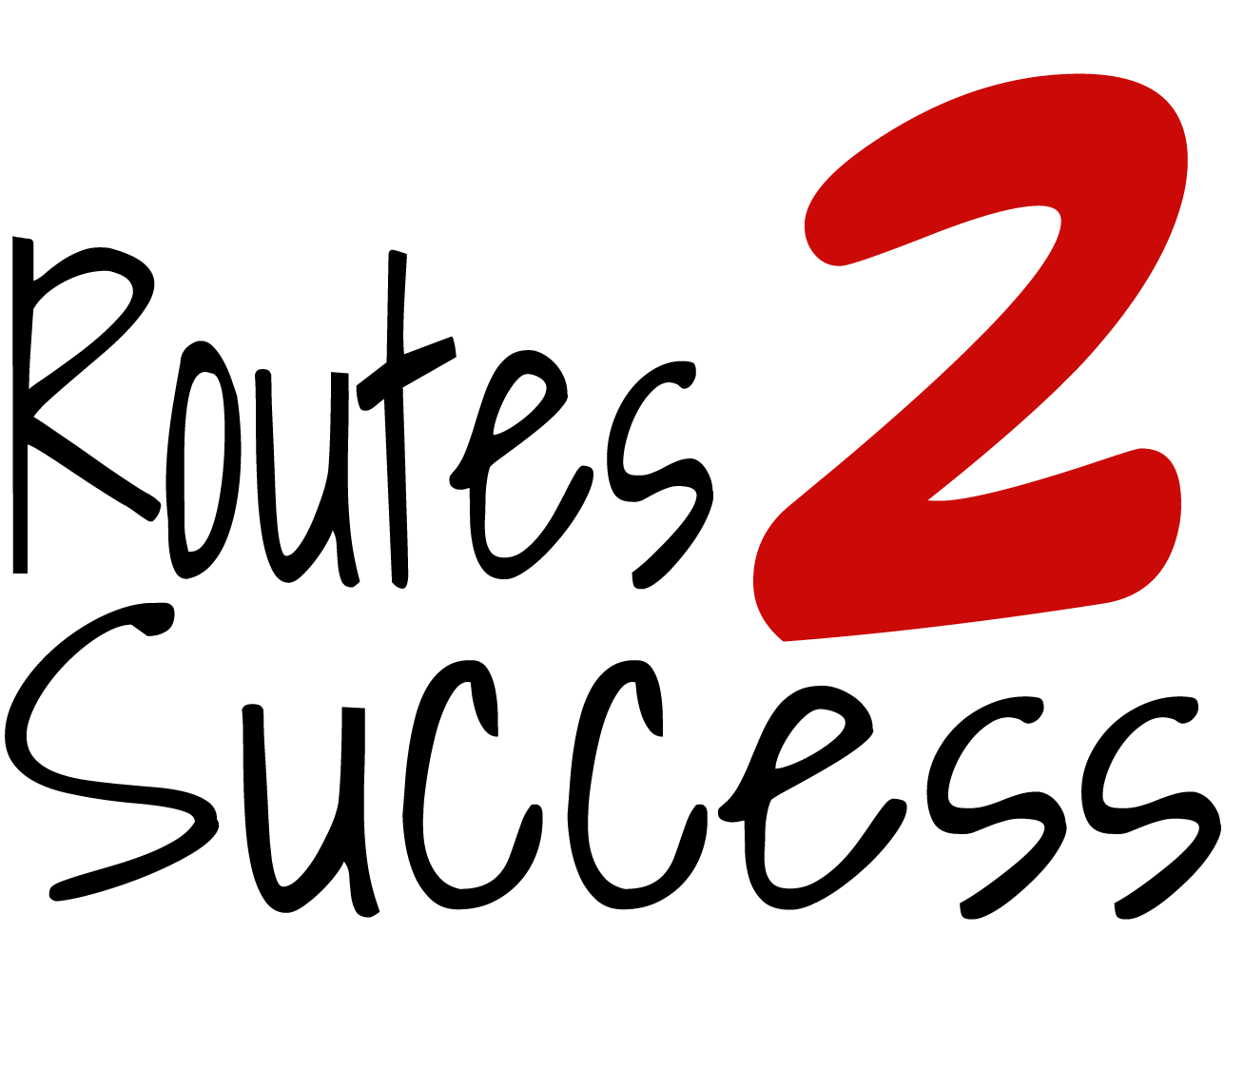
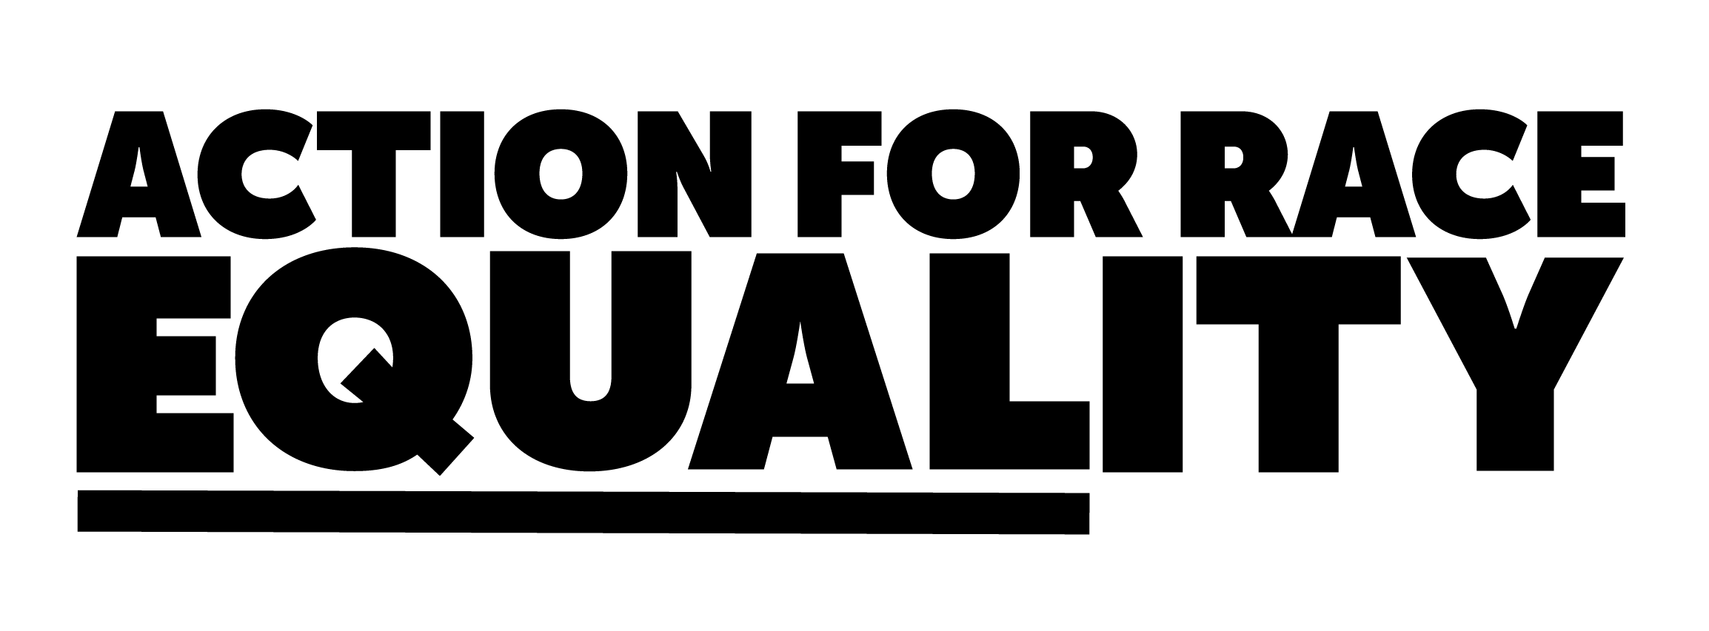

PROJECT DEVELOPMENT & ENGAGEMENT OFFICER
JOB DESCRIPTION
Ref: PDEO/R2S

This is an exciting new opportunity to join our successful Routes2Success (R2S) team and work with young people from Black, Asian and ethnic minority backgrounds aged 10-24. You will be responsible for setting up and overseeing Race Equality Action Projects (REAP) led by young people and supported our expert role models.

JOB TITLE: Project Development & Engagement Officer (R2S)

SALARY: £25,000 per annum

LOCATION: London (King’s Cross)

TYPE OF POST: Full-time

ACCOUNTABLE TO: Chief Executive and Board of Trustees

LINE MANAGEMENT: R2S Programme Manager

TIMING: 2-year contract subject to 3-month probationary review

BENEFITS: Stakeholder pension (8% employer contribution)

THE ROLE

Action for Race Equality (ARE) is a dynamic national charity based in Kings Cross (London). Our projects are delivered by a team of thirteen people. Our mission is to improve education, self-employment and employment outcomes for Black, Asian and Mixed heritage communities in England.

We are seeking to attract a talented and enthusiastic ‘can do’ individual to join our team. R2S has been inspiring young people, mostly in schools, for over a decade and we are now seeking to expand our work in London and strengthen our marketing and advertising of the project to external stakeholders. The successful candidate will have the commitment and skills to work with children and young people and the agencies that support them to set up a new project. The R2S team includes the Programme Manager, Project Coordinator and works with 25 volunteer role models and mentors that participate in events across London. This role entails regular travel to schools across London.

KEY TASKS

- Lead on setting up and supporting four R2S REAPs each year working closely with young people, expert role models, local groups, schools/Pupil referral units/colleges and other appropriate organisations.

- Liaise with the communications team to produce and maintain content for the R2S website and social media platforms about R2S REAPs.

- Liaise with ARE’s Senior Communications Officer to produce case studies and blogs based on the learning of the REAPs.

- Lead on the recruitment of role models, mentors and marketing material for the project.

- Develop and keep up to date ARE’s R2S database of contacts including young people and supporting organisations.

- To create and maintain database with evidence of the impact of the REAPs.

- Create resources and organise meetings for the execution of REAPs.

- Engage with R2S role models to provide support new local projects led by young people.

- Maintain an effective and efficient office environment. This will include:

  - managing R2S invoices and payments with the support of the Finance Manager
  - keeping an accurate record of R2S stakeholders and young people.
  - Filing and managing paperwork.
  - Producing certificates

- Produce report performance reports for the Programme Manager.
- Undertake any tasks that fall within the scope of the role thereby ensuring that the overall business and operational priorities of ARE are delivered in a timely and effective manner.

PERSON SPECIFICATION

Criteria required by the appointee to ensure job effectiveness.

EDUCATION AND FORMAL TRAINING/QUALIFICATIONS

Essential
- Educated to GCSE ‘A’ level (or Level 3 equivalent), including GCSE English and Maths

Desirable
- Relevant youth work vocational qualifications
- Relevant project management qualifications

RELEVANT EXPERIENCE AND KNOWLEDGE

Essential
- Experience of working on youth projects and as a team
- Experience of delivering objectives and targets to timescale
- Experience of direct work with the public and external stakeholders
- Experience of working with young people from diverse communities
- Excellent communication and networking skills
- Experience of designing, setting up and implementing successful projects
- Proven ability to manage and process information
- Strong commitment to race equality and diversity and youth empowerment

Desirable
- Successful track record in the youth sector
- Proven ability to manage and process information
- Experience of working in a school setting
- Experience of audit and quality assurance processes
- Experience of using social media to promote projects

COMPETENCIES

Essential
- Ability to communicate with young people including good listening skills
- Ability to manage workload and paperwork
- Can work accurately and pay attention to detail
- Good social media and website content creating skills
- Good interpersonal skills, including being courteous and tactful
- Ability to develop and initiate productive working relationships with a wide range of individuals/organisations
- Excellent written and verbal communication skills
- Able to think logically, clearly, creatively and problem solve
- Self-motivated and able to work under own initiative and as part of the team
- Ability to prioritise, plan and manage workload and deliver to tight deadlines
- Show sound competence in the use of standard office software with skills in Word, Excel, PowerPoint, and other packages

The successful candidate will undertake a Disclosure Barring Service check prior to employment.

Confidentiality

All employees must respect at all times the confidentiality of the organisation both internally and externally

Basis of contract

The post is part funded by the Greater London Authority for two years.

This is a pan-London project so regular travel will be essential.

To apply, download an application form and complete ARE’s monitoring form before Wednesday 27th September at 5pm. Details here.

For any questions or to arrange an informal chat about this role, email Programme Manager, Brianna Cyrus – Brianna@Actionforraceequality.org.uk

